Step-1: Start an existing container and perform some task in container.

**Command: # docker container start container_id**

**Status:**

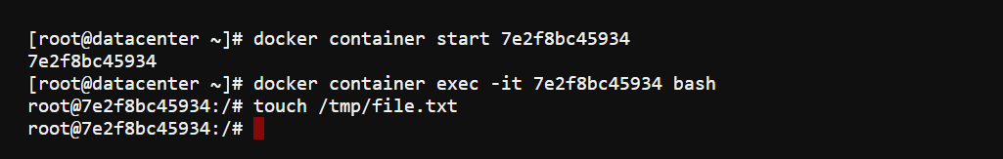

Step-2: Check out the “diff” command.

**Command:** # docker container diff container_id

**Status:**

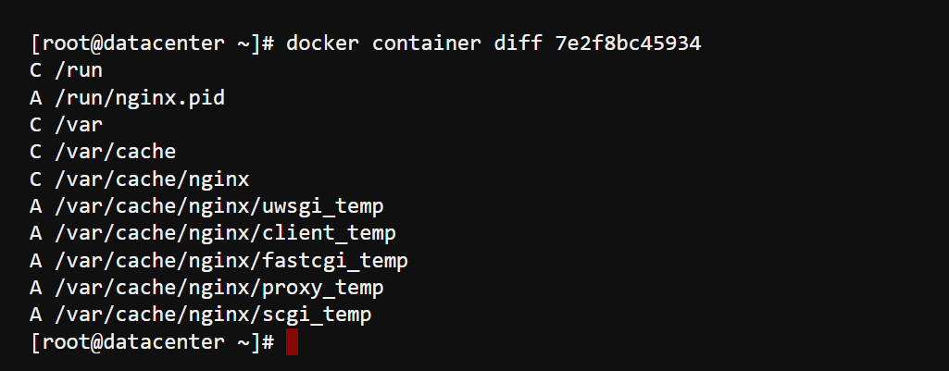

Again, Check the same command:

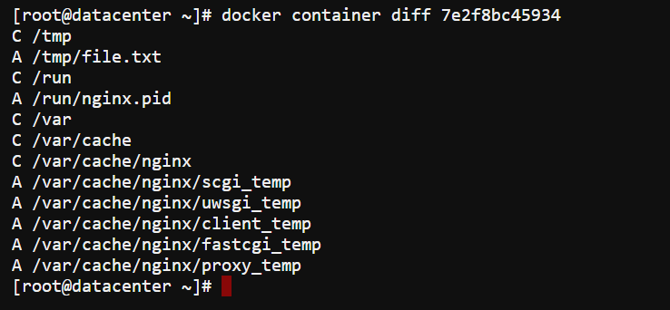

Step-3: Checking Logs for the container. #DO NOT USE IMAGE NAME

**Command: # docker container logs container_id**

**Status:**

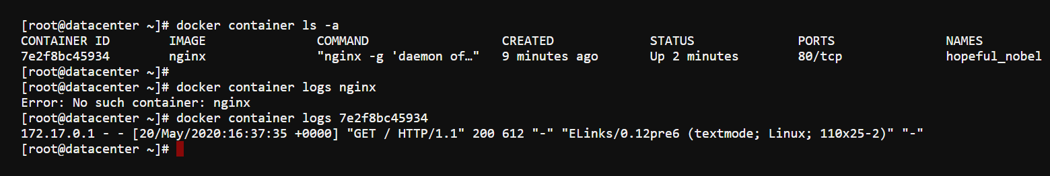

Step-3: Checking stat for the container. #DO NOT USE IMAGE NAME

**Command: # docker container stats container_id**

**Status:**

